USER MANUAL

- To execute the program open the terminal and navigate to the folder containing the program.
- Run the python script run.py. It compiles and executes the program and gives a graphical user interface to accept the inputs from the user.
- There is also a graphical representation of the above program. A 4-bit serial adder done by using python script with the aid of py graphics. It can be executed by giving 4 bit input and by pressing the simulate button.

Executing the above script gives the below display:

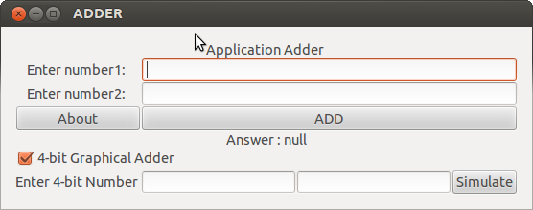

Sample input and output:

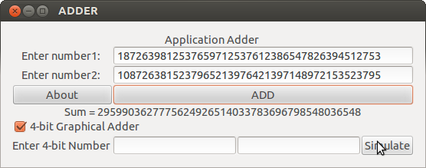

On clicking the about button

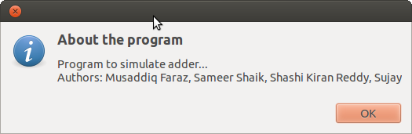

On clicking the simulate button with an appropriate input
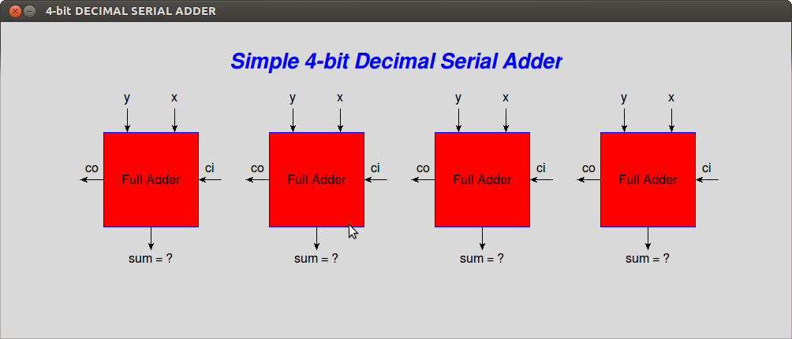

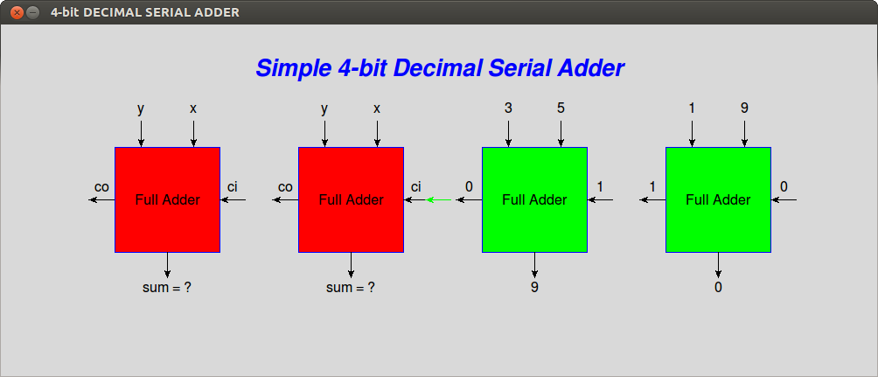

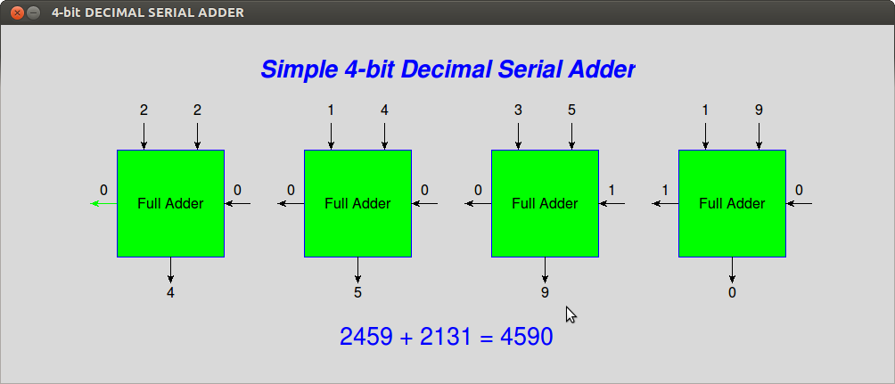

Toggle the check box 4-bit Graphical Adder to hide the 4 bit inputs

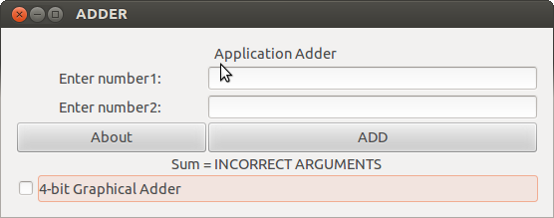

CONCLUSION

Pros:
- The project successfully compares the working of a serial carry ripple adder and the carry look ahead adder.
- The program serial adder successfully adds any large number with a time complexity of O(n) where n would be the number of digits in the number, which matches with the theoritical value.
- The fastadder implementation ideally executes with the time complexity of O(log(n)), and here again n is the number of digits.
Cons:
- The only con about the project would be failing to achieve the time complexity of O(log(n)) with the fast adder implementation.

ACKNOWLEDGEMENT

We would like to thank Dr.G.T.Raju H.O.D of Computer Science department of RNSIT for giving us the opportunity to build this project. We also extend our sincere thanks to Prof.Bhavani Shankar for supervising our project and Prof.Sathish Kumar for giving us useful information regarding parallel programming. We would also like to thank Prof.M.J.Sudhamani for giving us an outstanding lecture on the topic adder which is the base of our project.

Reference

- Computer Organization Lecture
- Python Documentation
- Wikipedia for history

